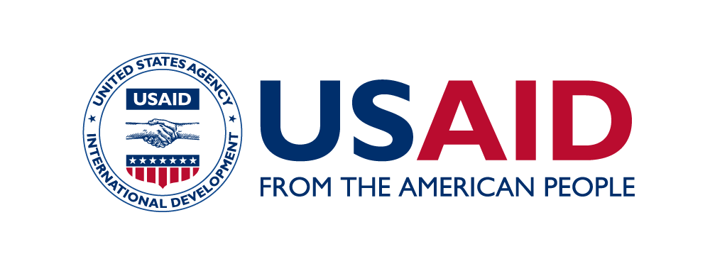
USAID Philippines, Pacific Islands and Mongolia
Outreach and Communications Strategy and Work Plan

VISION: Strengthened U.S.-Philippines, Pacific Islands and Mongolia partnerships to achieve mutual development goals
PURPOSE: Enhanced recognition by key audiences about how USAID advances prosperity, stability and self-reliance, by using effective and efficient approaches

Sub-Purpose 1: Strategic outreach activities heighten engagement on key development themes that are of shared interest with host country government .
Key Outputs | Key Activities | 2018 Targets | Person(s) Responsible
1.1 Strategic regional visits conducted to raise USAID’s profile in the region and for Washington audiences | -Proactively plan for and support high-level outreach visits; always have major hook (event w/ major publicity), then have side visits with beneficiary interaction  -Post on social media within 24 hours of most events, sometimes live with participant engagement (e.g. asking co-participants for Twitter handles/FB names, asking participants to use hashtags)  -Provide expert guidance on event planning, press coverage, talking points, multi-media support | -At least four Mission Director-level visits a year (quarterly)  - Puerto Princesa  - Batangas  - Davao  - Mindanao (CDO, Zamboanga?)  -At least one Pacific Islands visit | Ted, Kiel
 |  | -At least three outreach visits or major events for the U.S. Ambassador to the Philippines planned and conducted (Marawi rice turnover, TB projects launch, Seal of Good Governance awarding) | Kiel, Josie
 |  | -At least 100 new page likes/followers during and within three days of high-level road shows, especially from key influencers | Jeff
 | -Manage event calendar and planning (Ted)  -Review, management and technical guidance on scene setters, including both event logistics and content (Ted) | -100 percent of talking points/remarks for USAID public events prominently convey at least one of the key development themes | Ted (Office Chief-level)  Ted, Kiel (MD-level)  Kiel, Josie (Ambassador-level)  Josie (overall)
1.2 Social media campaigns raising awareness on key development themes designed, launched and evaluated, in partnership with technical teams, PAS and implementing partners | -Update development themes calendar monthly (Liana), disseminate to IPs (Kiel) and mission (Kiel/Jeff)  -Work with technical teams to identify themes, develop objectives and content, engaging technical team POCs and IPs  -Conceptualize appropriate and engaging content that reaches a defined target audience with a specific purpose  - Proactively engage partners and key influencers through use of handles, hashtags, friend requests  -Regularly send PAS suggested content to share on their channels (Liana, Jeff)  -Develop and/or edit high-quality pictograms and videos as appropriate (Jeff)  -Develop monthly social media analytics summaries (Jeff) + discuss at end-of-month staff meetings to evaluate and strategize  -Use sponsored posts, as appropriate (Jeff) | -At least one major social media campaign (5-7 days) a month, with at least half of these campaigns with additional multimedia coverage (radio, TV, etc.)  -Dedicated Marawi campaign throughout the year  -Total engagement for major campaigns reaches 2,000 | Liana (technical content)  Ted (multimedia)  Jeff (web support)
1.3 Enhanced media coverage of USAID work | -Proactively plan for and write press releases (Liana)  -Prepare and clear press releases and social media posts concurrently with scene setters, when possible  -Work with PAS on enhancing engagement with their media channels  -Track media mentions (Jeff)  -Provide high-level media mentions/summaries for bi-weekly updates (Ted?) | -At least two planned press or photo releases a month  -At least three USAID-centric media features conceptualized, conducted and aired on major national media outlet  -At least four positive and prominent USAID media mentions per month | Kiel

Sub-Purpose 2: Strategic communications help raise USAID’s profile in the region.
Key Outputs | Key Activities | 2018 Revised Targets | Person(s) Responsible
2.1 Relevant and timely content developed and disseminated | -Work with technical teams and IPs to develop engaging stories  -For select stories, travel to field for photography and interviews (Ted and Liana)  -Engage IPs for audio-visual presentations (Ted) | -At least one major story published month, in sync with the month’s campaign | Liana
2.1 Relevant and timely content developed and disseminated | -Update portfolio handbooks,  country profiles, select cross-cutting fact sheets | -Country Profiles updated with new messaging framework  -Philippines and Pacific Portfolio handbooks updated semi-annually, triggering website updates  -Mongolia activity briefers updated as needed | Kiel + team (Portfolio Handbooks)  Liana + team (Country and Sector Profiles)
2.2. Access to information by target audiences improved | -Regularly update websites and social media (SM), including Flickr  -Regularly update of Outreach intranet site to make key documents (e.g. scene setter templates, writing guide) accessible to staff  -Routinely conduct, share, discuss and utilize analytics of reach  -GIS data management and external comms (Jeff)  -Make links to Embassy websites, as appropriate | -60,000 page views of website (PH)  -5,000 page views of website (PI)  -Average SM monthly reach 500,000 (PH)  -Average SM monthly reach 10,000 (PI)  -100% of USAID open and FB private messages responded to or routed to the relevant office within seven days | Jeff (technical and web support)
Sub-Purpose 3: Collaboration enhanced among internal stakeholders (USAID staff, implementing partners, Public Affairs Section)
Key Outputs | Key Activities | 2018 Revised Targets | Person(s) Responsible
3.1 Improved technical consultations with USAID staff | -DOC/PRM backstops regularly attend technical office meetings and periodically deliver learning sessions about a relevant topic (e.g. social media, writing)  -Prepare monthly and weekly summaries for senior management on social media analytics and DOC updates (Josie/Jeff)  -Expand opportunities for internal and external communications on learning from project implementation (Josie)  -Participate in project design, activity design and/or work planning when development communications is a significant component of a design | -At least four capacity building workshops for staff and IPs: writing for speeches, branding, iphone photography, public speaking, effective social media posts and use | Josie + team (Learning Sessions)  DOC/PRM backstops:  -Kiel (OEDG)  -Ted (EO)  -Liana & Josie (OH)  -Jeff & Chris (OED)
3.2 Improved collaboration with IP DOCs | -Attend post-award briefings and review branding and marking plans  -Organize semi-annual implementing partners’ meetings with IP DOCs, or as needed  -Send regular e-mail to IP DOCs on calendar themes, good practices, branding and marking, writing tips, etc. (Kiel)  -Mentor select new DOC IP POCs of high-profile activity (Kiel, Liana)  -Should there be a specific anticipated output, explore buy-in option for photography | -100% of post-award briefings are attended by a DOC staff  -100% of social media, branding and marking plans are cleared by a DOC staff within 7 working days  -DOC Training for new activity staff  -At least two implementing partners’ meetings per year with IP DOCs focused on capacity strengthening, including virtual meetings w/ Pacific staff  -One informative group e-mail per month to IP DOCs, copying A/CORs, including those in the Philippines, Pacific and Mongolia | Ted and Kiel (Post-award briefings and Branding & Marking Plans)  Kiel (IP e-mails)
3.3. Strengthened coordination with PAS | -Coordinate on media and social media approaches  -Semi-annual calls with Pacific Island Embassy PAS  -Regular attendance at U.S. Embassy Philippines’ PAS meetings (Kiel, Josie [monthly])  -Regular attendance at PAS country team meetings? | -AMB road shows jointly coordinated with PAS  -At least five social media campaigns jointly prepared with PAS | Josie and Kiel (strategy)  Jeff and Liana (social media)

host country government, Washington influencers, American taxpayers, Filipino citizens, beneficiaries, private sector
Security, prosperity, democracy, stability, inclusive growth, sustainability, partnerships, gender, Mindanao, Cities Development Initiative,
Includes reactions, post clicks, comments and shares

