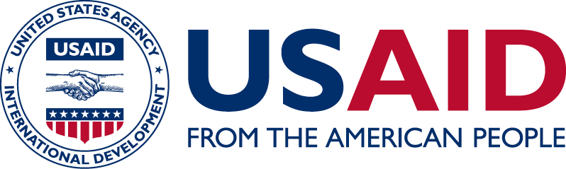
PHILIPPINES
Country Profile
A long-time ally of the United States and the oldest democracy in Southeast Asia, the Philippines is a key partner in promoting sustainable and inclusive development in the Indo-Pacific. While the Philippines has emerged as one of the fastest growing economies in the region, economic benefits have not reached all Filipinos. The United States works with the Philippines to counter violent extremism, promote inclusive socio-economic growth, democratic governance and human rights.
Photo credit: USAID STRIDE
USAID partners with the Philippines to drive inclusive economic growth and promote peace and stability. USAID builds self-reliance by strengthening the Philippines’s ability to plan, finance and implement its own development solutions.

Our Work
An archipelago of more than 7,500 islands, the Philippines is divided into three geographical areas – Luzon, Visayas and Mindanao. Focusing on strengthening economic growth, democratic governance, health and education, USAID partners to advance sustainable, inclusive development for all Filipinos. USAID also aims to forge lasting peace and stability in conflict-affected areas of Mindanao, improve natural resource management and boost environmental resilience.

economic growth, GOVERNANCE, HEALTH AND EDUCATION
Limited foreign investment, constrained access to quality public services and an aggressive anti-drug campaign threaten the prosperity and security of the Philippines. To encourage investment, USAID promotes reforms that create a favorable environment for businesses to thrive, including American companies. Bolstering democratic governance, USAID strengthens access to justice, political participation and local governance. Supporting the Philippines’ commitment to improving health and education, USAID helps the country achieve its goal of sustaining a healthy population, boosts early-grade reading and strengthens university education curricula.

PEACE AND STABILITY IN MINDANAO
Seven of the Philippines’ ten poorest provinces are located on the southern island of Mindanao, stamping out opportunities for young people and making way for rebel groups and extremists — including from other countries — to take root. In response to the 2017 ISIS-linked insurgency in Marawi City, which displaced hundreds of thousands of Filipinos, USAID supports humanitarian and longer-term revitalization efforts for displaced populations and offers alternatives to violent extremism.

ENVIRONMENT
Millions of Filipinos rely on agriculture, forestry and fisheries for their livelihoods; yet, frequent natural disasters — which cost the Philippines about $5 billion annually — threaten these critical natural resources. Bolstering the country’s environmental resilience, USAID helps improve the management of over 90 percent of Philippine forests — natural resources that help prevent erosion, provide energy water and other environmental benefits.
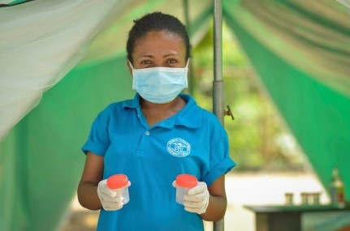
USAID has successfully treated more than 1 million Filipinos with TB over the last five years.
Photo Credit: usaid impact

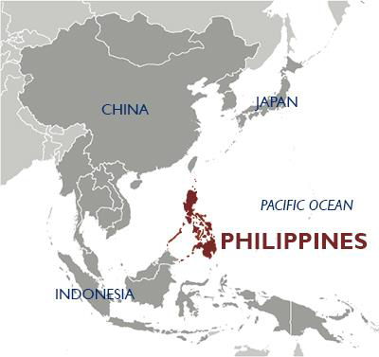

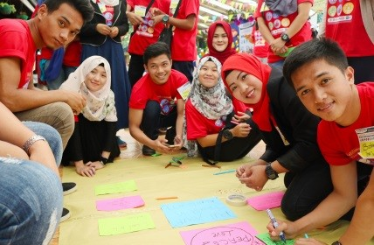
Since 2013, more than 20,000 youth have participated in USAID’s life skills and leadership trainings in conflict-affected areas of Mindanao.
Photo Credit: USAId mydev

Contacts

Mission Headquarters
Lawrence Hardy II, Mission Director Michael Glees, Desk Officer
U.S. Embassy, Roxas Boulevard, Ermitas U.S. Agency for International Development
Manila, Philippines 1000 1300 Pennsylvania Avenue, NW
Phone: 632-301-6000 Washington, DC, USA 20523
E-mail: infoph@usaid.gov Phone: 202-712-4728 • E-mail: mglees@usaid.gov
CLEARANCE PAGE FOR PHILIPPINES

Drafted 10/9/2018 by PRM/JFrancisco and LMeyer based off of cleared materials

Cleared:

USAID/Philippines PRM JFrancisco
USAID/Philippines (A)MD PWesner
ASIA/EAA: MGlees
ASIA/EAA:
ASIA/SPO:
ASIA/DAA:
ASIA/SDAA:
ASIA/AA:

